WEEK 3
Task1
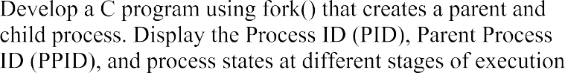

Source Code:
#include <stdio.h>
#include <unistd.h>
#include <sys/types.h>
#include <sys/wait.h>
#include <stdlib.h>

int main() {
pid_t pid;
printf("Parent Process Started\n");
printf("Parent PID : %d\n", getpid());
printf("Parent PPID : %d\n", getppid());
pid=fork();

if (pid<0) {
printf("Fork failed\n");
return 1;
}
else if (pid==0) {
printf("Child Process\n ");
printf("Child PID : %d\n", getpid());
printf("Child PPID : %d\n", getppid());
printf("Child State: Running\n");
sleep(5);

printf("Child State: Terminating\n");
exit(0);
}
else {
printf("Parent Process\n ");
printf("Parent PID : %d\n", getpid());
printf("Child PID : %d\n", pid);
printf("Parent State: Running\n");
sleep(2);
printf("Parent State: Waiting for child\n");
wait(NULL);

printf("Parent State: Child Terminated\n");
}
return 0;
}

Output:
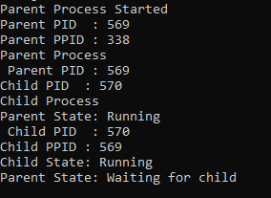

Task2
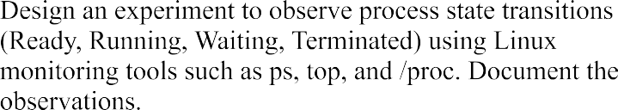

Source Code:

#include <stdio.h>
#include <unistd.h>
#include <sys/wait.h>
int main() {
pid_t pid = fork();
if (pid == 0) {
printf("Child process started. PID = %d\n", getpid());
sleep(10);
printf("Child process terminated.\n");
}
else {
printf("Parent process started. PID = %d\n", getpid());
printf("Child PID = %d\n", pid);
wait(NULL);
printf("Parent: Child terminated.\n");
}
return 0;
}

Output:
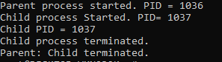

- ps: displays the processes that are currently running in the system.

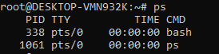

- top: It is used to monitor processes. It displayed the PID, user, cpu details, memory usage, and process state.

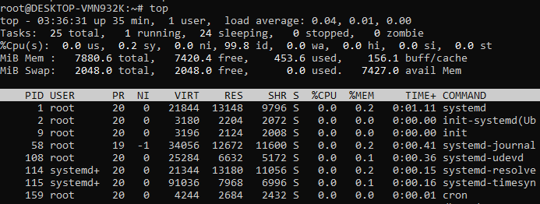

- /proc: It is a directory

